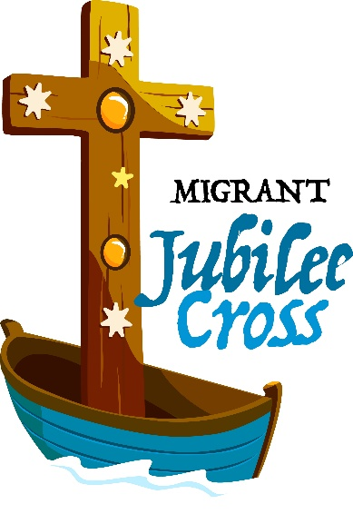

Pilgrimage of the Migrant Jubilee Cross

Insert Image of Deacon Greg Here

This Easter, we are welcoming the pilgrimage of the Migrant Jubilee Cross and invite you and your parish community to take part in a special moment in the life of the Church.

Deeply symbolic and sacred, the Migrant Jubilee Cross is a gift from migrant communities to the Church.

Set on a boat-shaped base, the cross is made from Australian recycled timber and incorporates the Southern Cross constellation - deepening its connection with the land.

It also contains sacred relics of the Holy Family and a relic from the 1914 cedar coffin of St Mary of the Cross MacKillop.

The Migrant Jubilee Cross is symbolic of the faith, gifts, contributions and resilience that migrant communities bring to the church and the world.

Its journey was officially launched on 5 October 2025 at St Christopher’s Cathedral in Canberra to coincide with the World Day of Migrants and Refugees, and the Jubilee of Migrants.

The launch marked the beginning of a year-long national pilgrimage that will see the Jubilee Cross received at 28 dioceses and four eparchies across Australia.

The cross will be welcomed to Perth at a special Mass that will be celebrated at St Mary’s Cathedral on Saturday 18 April by Archbishop Timothy Costelloe.

Between Sunday 19 April and Sunday 3 May it will be hosted by various parishes, schools and groups, providing the faithful with a unique opportunity for pilgrimage.

Deacon Greg Lowe
Director, WA Catholic Migrant & Refugee Office

The following resources can be used to assist you to Plan Your Pilgrimage.

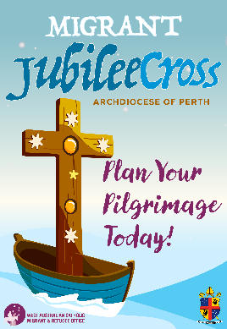
Host Parishes

Select the host parish that is most convenient for you to participate in the pilgrimage. To download the host parish itineraries, Click Here (link to Cross Locations and Itineraries.xlsx)

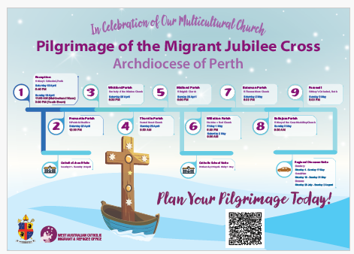
ROADMAP

See where the Migrant Jubilee Cross will visit during its time in the archdiocese. To download the Migrant Jubilee Cross Roadmap, Click Here (link to Migrant Jubilee Cross Roadmap.pdf)

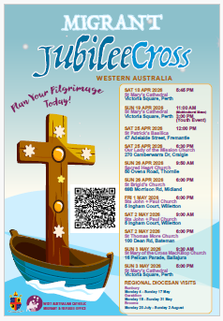
POSTER

Display the official Migrant Jubilee Cross poster. To download the Migrant Jubilee Cross Poster, Click Here (link to Migrant Jubilee Cross Poster.pdf)

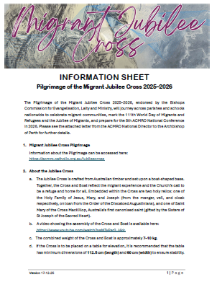
GENERAL INFORMATION

Find out more about the Migrant Jubilee Cross including assembly instructions. To download the information sheet, Click Here (link to Information Sheet.pdf)

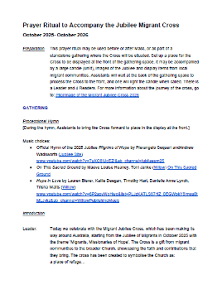
PRAYER RITUAL

A prayer ritual has been developed to accompany the Migrant Jubilee Cross. To download the Prayer Ritual, Click Here (link to Prayer Ritual to Accompany the Cross.pdf)

